Board Member Induction Outline
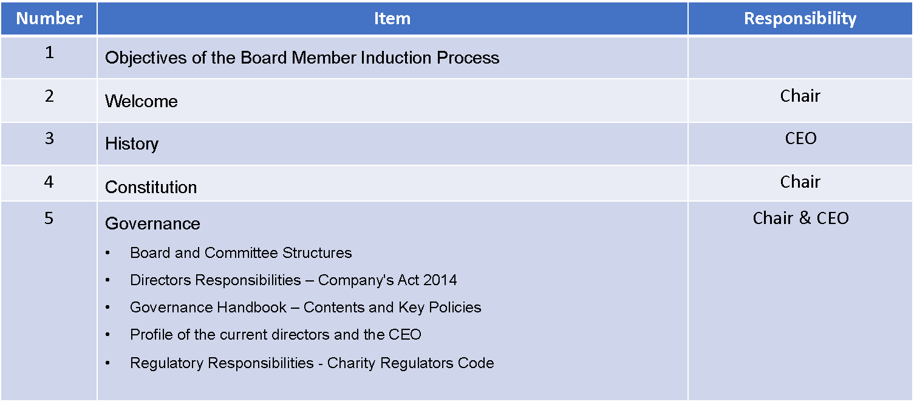
 | Item | Responsibility
6 | Strategic Plan, Implementation Plan and Annual Business Plan | Chair & CEO
7 | Organisation Structure and Key Services | CEO
8 | Annual Report and Financial Statements | CFO
9 | Finance – Business Model and Current Budget | Chair of Finance Audit and Risk, CFO
10 | Directors & Officers Insurance
11 | Other matters  - Meet the staff  - Minutes – last 12 months  - Annual Board Work Plan and Schedule of meeting for the next 12 months | CEO / Company Secretary

